Getting started
  - Documentation for the FSC Identikit



Original development funded by the Esmée Fairbairn Foundation and the Heritage Lottery Fund

Contents
1 Contents 2
2 Introduction 3
3 Install FSC Identikit 3
4 Set up your computer to run Identikit locally 4
5 Run Identikit 5
6 Create a new knowledge-base and visualisation 6

Introduction
The FSC Identikit is open source software for creating new identification resources that run as ‘web apps’ in web browsers. You can use the Identikit to create a new ID web app simply by creating a knowledge-base using a spreadsheet.
But it’s not always convenient or desirable to run your app on a website, especially while you are developing a new knowledge-base. The good news is that you don’t have to. Instead, you can run it on your own computer using the development environment that comes with Identikit.
These instructions tell you:
- How to install the Identikit on your computer.
- How to set up your computer to run Identikit.
- How to start a new knowledge-base and web app of your own.
Note that these instructions are written from the point of view of Windows users and minor details will be different on platforms such as Linux and Mac. Users of those platforms will need to make those minor adjustments. For example we talk about opening a Windows ‘command window’ – users of other platforms need to use the equivalent tool.



Install FSC Identikit
These are the steps for installing the Identikit on your computer.
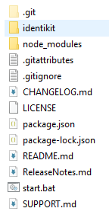
- Download the latest version of the Identikit from https://github.com/FieldStudiesCouncil/tombiovis/releases - download the latest ‘Source code (zip)’ file.

- Unzip the Identikit zip file to a convenient location on your computer.
The Identikit is delivered as a zip file. Once you’ve downloaded and unzipped this file you will find a folder called something like: tombiovis-1.2.3 (the version number will be different). If you have a look in this folder you will see some folders and files similar to those shown on the right.

Set up your computer to run Identikit locally
There are many ways you could set up your computer to run the Identikit web app without deploying it to a website. As of version 1.9.0 of Identikit, we recommend using some Node JS tools, including Electron. Follow the steps below to do this.
- Unless you already have it installed, go to the Node JS download page – https://nodejs.org – and install Node JS.

- Open a Windows ‘command window’ in the folder where you installed the Identikit by double-clicking the start.bat file.

- In the command window, type the following command: npm install
Running ‘npm install’ installs additional Node packages (including Electron) into a folder called ‘node_modules’ in your identikit folder. Once this is done, Identikit is ready to run. Note that step 1 above only needs to be done once on your computer. Steps 2 and 3 need only be repeated when you download and unzip a new version of the Identikit software.

Run Identikit
Once you complete the steps above, you need only type npm start in the command windows and hit return to start the Electron window. From the web page that starts in Electron, select the link to the kb/biscuits test knowledge-base with the standard interface.
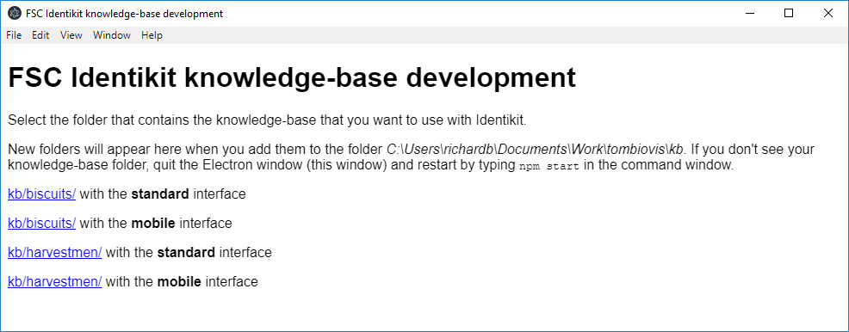
Clicking the kb/biscuits link for the standard interface starts Identikit in the Electron window.
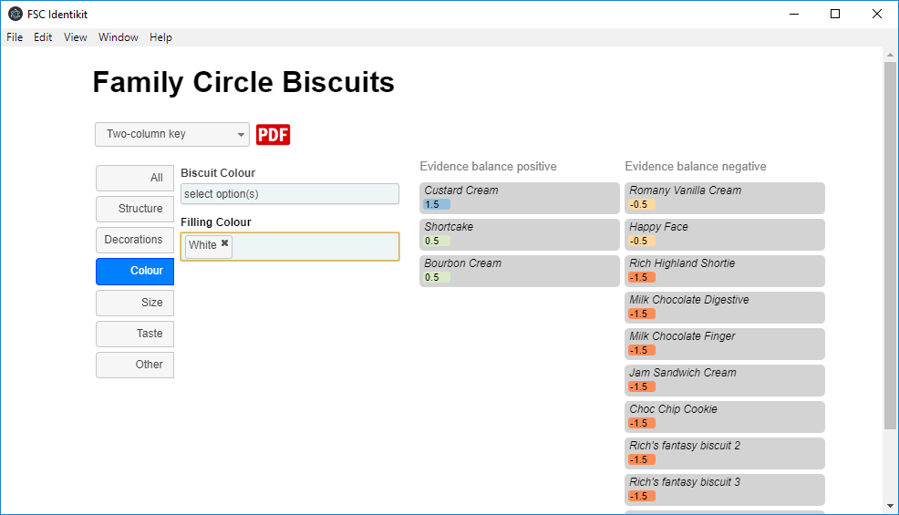
Note that when an ID resource created with Identikit is deployed to a website, it simply runs in any modern web browser like, Chrome, Edge, Safari or Firefox – Node JS and Electron are not required by users of Identikit ID resources deployed on websites.

Create a new knowledge-base and visualisation
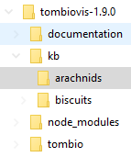
It is unlikely that you downloaded the Identikit to obtain an idenfication resource for biscuits! Its more likely that you want to have a go at creating a new knowledge-base of your own to drive a new ID resource. Here’s one way you can make a start. (You are given only the very briefest introduction to creating a knowledge-base below. For a proper guide you should read the Building a knowledge-base document included with the Identikit.)
- In the ‘kb’ folder under the main folder, create a new folder corresponding to the resource you’d like to make, e.g. ‘arachnids’.

- Copy the file ‘kb/biscuits/biscuits.xlsm’ into your new folder and rename it, e.g. ‘kb/arachnids/arachnids.xlsm’.
title | metadata | yes | Family Circle Biscuits
year | metadata | yes | 2016
authors | metadata | yes | Bell, C.
publisher | metadata | no | Field Studies Council
location | metadata | no | Preston Montford, Shrewsbury
- Open your new Excel file (e.g. arachnids.xlsm) for editing. (You need to ensure that macros are ‘enabled’ – so respond accordingly to any questions.) On the ‘config’ worksheet, change the values of the title, year, authors, publisher and location keys. (You can leave the values of publisher and location blank if you like.) Also delete one of the release history lines and edit the remaining one to something suitable.

- Go to the ‘macros’ worksheet and click the ‘Save worksheets as CSV’ button. This creates five CSV files in the same folder as your knowledge base with the names, taxa.csv, characters.csv, values.csv, media.csv and config.csv. Identikit reads these CSV files – not the spreadsheet – so you must repeat this step every time you modify the knowledge-base.

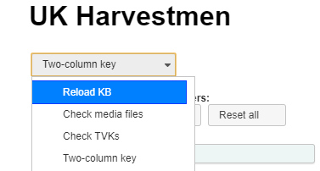
- At this point you should be able to run Identikit (see ‘Run Identikit’ above – being sure to select the link to your new knowledge-base). Once your Identikit is running on your new knowledge-base you don’t need to restart it every time you make a change to your knowledge-base, instead you simply select the ‘Reload KB’ option, from the drop-down list to pick up the updated knowledge-base after you’ve use the ‘Save worksheets as CSV’ macro button.
Currently it will look just like the biscuits knowledge-base because you haven’t changed anything except some configuration metadata. To confirm that you are picking up your new knowledge-base, scroll down to the bottom of the Electron window, you should see a citation derived from the information you entered on the ‘config’ worksheet. Now you’ve created a new knowledge-base and you understand how to run a visualisation from it on your computer and make changes. All that’s left to do now is populate the knowledge base with real information! For instructions on that, read the ‘Building a knowledge-base’ document and/or look at some of the videos on this page: https://www.fscbiodiversity.uk/fullscreen/identikit

